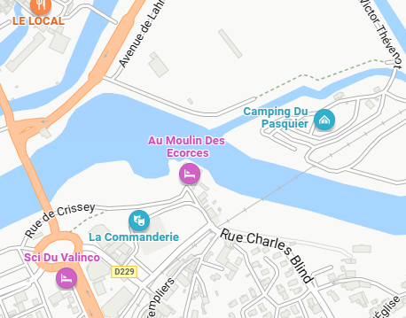

Parking Lahr

Parking Commanderie

Parking Lahr

Parking Commanderie